

**EXTRACTING TEST CASE, TEST SCRIPT AND TEST PLAN IN XML**

**Table of Content**

1. Overview 3

1.1 File Structure 3

1.2 Deployment 4

1.3 Configuration 5

1.4 Adding as widget to RQM 5

# Overview

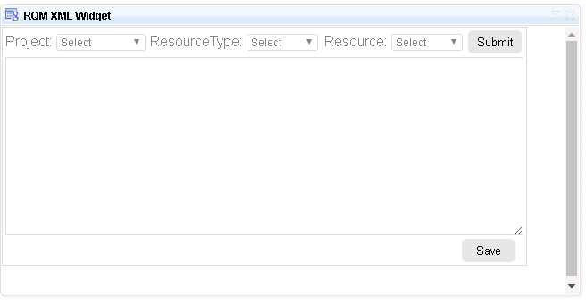RQM XML widget is a web page extension to provide resource based XML data files. The widget requires RQM logged in session, if not logged in or the session expires then widget will fail to get data from server resulting in error. Also the widget must be hosted in same domain as the RQM application is hosted.

As shown in image below, the Projects drop down lists all the projects available; the Resource Type can be either ‘Test Case, Test Plan or Test Script’. Based on this selection criteria Resource drop down will be loaded with resources available. On Submit the xml related to particular resource will be displayed in text area, which can be later saved to an xml file on disk.

## File Structure

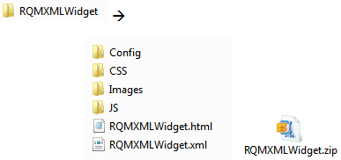

Widget consists of main root folder ‘RQMXMLWidget’. RQMXMLWidget.html is the form web page which comprises entire user interface. Under JS folder RQMXMLWidget.js is the JavaScript file which does the work of getting the XML data from RQM API, formatting of data in order to bind data to drop down controls.

RQMXMLWidget.xml file has the widget creation code which RQM recognizes and a copy of code from RQMXMLWidget.html as the widget contents.

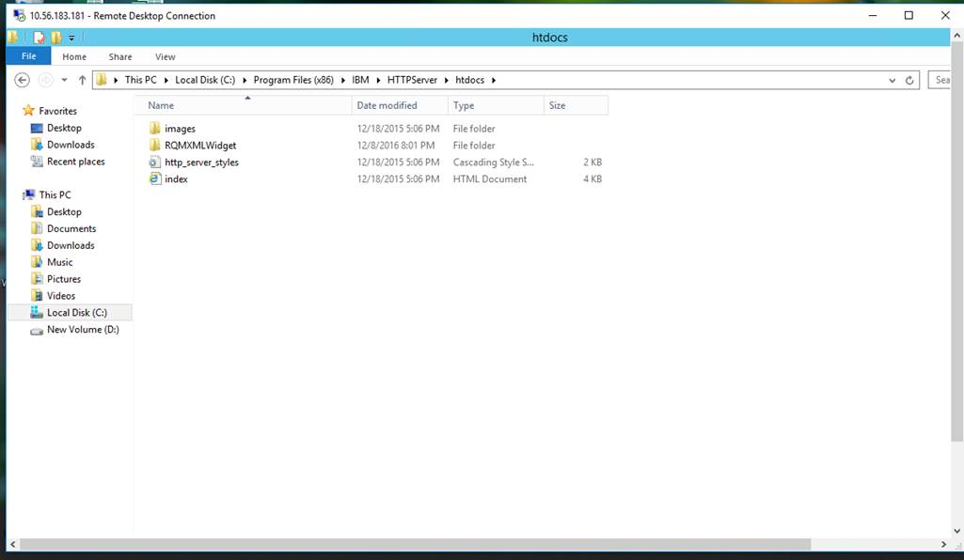This complete folder needs place in below path of server.

## Deployment

The widget must be deployed on same domain server as the RQM is, otherwise the widget will fail to call RQM API because it will be considered cross domain request resulting in errors. Once deployed RQMXMLWidget.html page can be directly browsed in the browser. For deployment copy and paste entire RQMXMLWidget folder to “\Tomcat 7.0\webapps\” folder, once finished try browsing the page in web browser with URL as for example,

<https://server.com:port/RQMXMLWidget/RQMXMLWidget.html>

|  |  |
| --- | --- |
| NOTE | The URL is case sensitive. |

## Configuration

The URL for the API has to be configured before adding the widget. Edit the property ‘integrationUrl’ in file Config/config.js; it should point to deployed RQM application path. Update the highlighted URL to deployed application path.



## 

## Adding as widget to RQM

On RQM Dashboard click on Add Widget link, below window will be displayed.

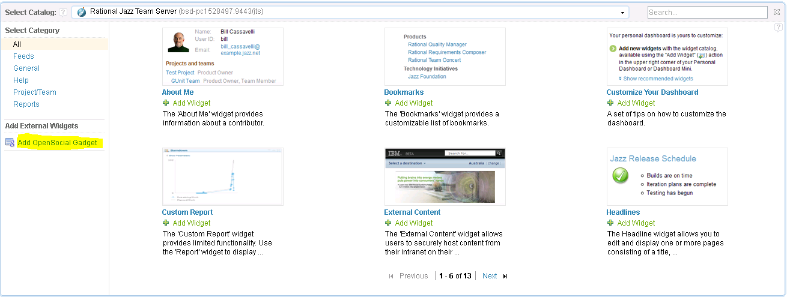

Click on Open Social Widget link

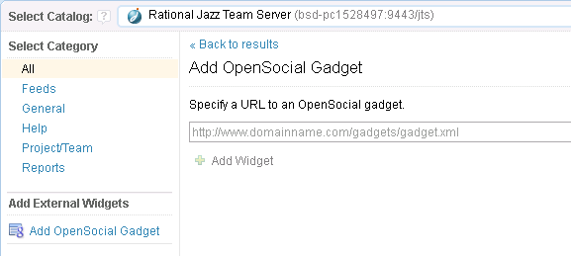

In Specify a URL enter the full deployment path for RQMXMLWidget.xml file and click on Add Widget button below.

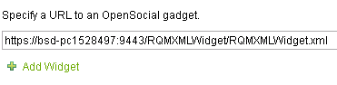

The widget will get added to the dashboard.

Specify your criteria and click on submit to get the XML data for the resource. Save button will download the file to disk.

**Disclaimer**

Tech Mahindra, herein referred to as TechM provide a wide array of presentations and reports, with the contributions of various professionals. These presentations and reports are for informational purposes and private circulation only and do not constitute an offer to buy or sell any securities mentioned therein. They do not purport to be a complete description of the markets conditions or developments referred to in the material. While utmost care has been taken in preparing the above, we claim no responsibility for their accuracy. We shall not be liable for any direct or indirect losses arising from the use thereof and the viewers are requested to use the information contained herein at their own risk. These presentations and reports should not be reproduced, re-circulated, published in any media, website or otherwise, in any form or manner, in part or as a whole, without the express consent in writing of TechM or its subsidiaries. Any unauthorized use, disclosure or public dissemination of information contained herein is prohibited. Unless specifically noted, TechM is not responsible for the content of these presentations and/or the opinions of the presenters. Individual situations and local practices and standards may vary, so viewers and others utilizing information contained within a presentation are free to adopt differing standards and approaches as they see fit. You may not repackage or sell the presentation. Products and names mentioned in materials or presentations are the property of their respective owners and the mention of them does not constitute an endorsement by TechM. Information contained in a presentation hosted or promoted by TechM is provided “as is” without warranty of any kind, either expressed or implied, including any warranty of merchantability or fitness for a particular purpose. TechM assumes no liability or responsibility for the contents of a presentation or the opinions expressed by the presenters. All expressions of opinion are subject to change without notice.

**Thank You**

Visit us at [www.techmahindra.com](http://www.techmahindra.com)